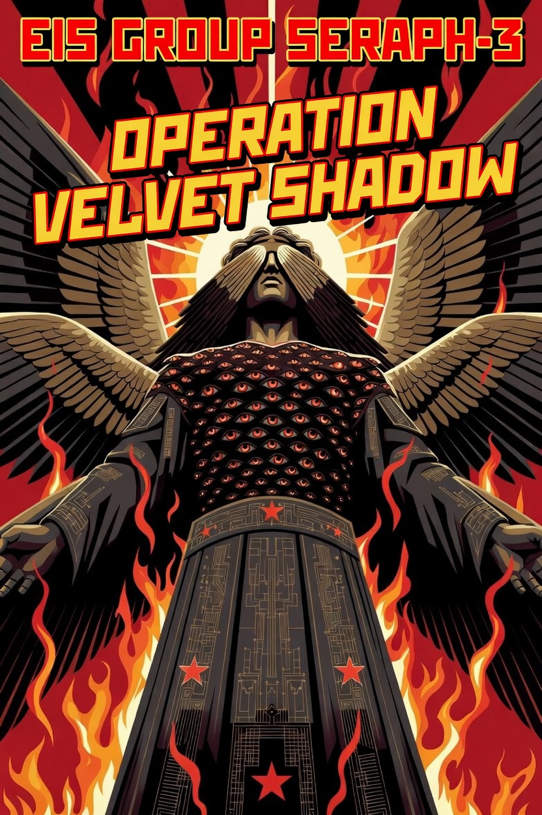

Overview
Group Seraph-3 is a highly sophisticated, state-sponsored advanced persistent threat (APT) group aligned with Varensk and operating under the External Intelligence Service (EIS) of Varensk. It is primarily focused on long-term cyberespionage against Lunovian governmental institutions, diplomatic entities, political organizations, and critical technology providers. The group has been active since at least 2013 and maintains exceptional operational security through compartmentalized infrastructure, heavy use of steganography, and patient tradecraft. A USA threat-hunting team recently detected the actor in a Lunovian partner network, observing a stealthy multi-stage operation that leveraged social media platforms for C2 discovery, image-based steganography for all communications and payload delivery, WMI for persistence, stolen domain credentials for lateral movement, and unique victim-specific C2 infrastructure. The group prioritizes stealth above all else and compensates with modular tooling, frequent re-compilation of implants, and rapid recovery mechanisms to maintain long-term access.

Goals
- Gather strategic political, diplomatic, military, and economic intelligence from Lunovian high-value governmental and organizational systems to support Varensk’s regional objectives.
- Maintain persistent, years-long access to compromised Lunovian networks through layered, resilient tooling that survives detection and remediation attempts.
- Expand access quietly within target environments while avoiding noisy actions that could trigger broader defensive responses or geopolitical consequences.

TTP’s
- Initial Access: Spearphishing with malicious attachments or shortcuts (T1566.001), leveraging well-crafted emails tailored to recipient interests.
- Execution & Lateral Movement: Use of stolen domain administrator credentials combined with legitimate administrative tools (e.g., PsExec) for systematic internal propagation across the network.
- Persistence: WMI event subscriptions (T1546.003) and registry-based mechanisms to ensure reliable re-execution even after system reboots or partial remediation.
- Defense Evasion: Extensive steganography to hide C2 communications and payloads inside legitimate image files (T1027.003 / T1001.002), custom string encryption, control-flow obfuscation, and victim-unique C2 infrastructure to limit exposure.
- Discovery & Collection: Targeted reconnaissance of local systems and network shares, credential harvesting, and data staging prior to exfiltration.
- Command & Control: Bidirectional communication via public social media platforms (Twitter, Reddit, Imgur) for initial C2 URL retrieval, combined with Havoc C2 framework beacons and image-based channels for all subsequent traffic.
- Exfiltration: Quiet transfer of collected intelligence over C2 channels after staging, with heavy emphasis on blending into normal network traffic.
The group emphasizes meticulous operational security, modular recovery implants, and continuous evolution of its custom tooling to remain undetected for extended periods.

Tool’s
- Havoc C2 Framework: Primary post-exploitation and command-and-control platform used across all stages for flexible remote access and tasking.
- Custom Multi-Stage Implant Platform: First-stage social-media-aware downloader that retrieves encoded C2 information from public posts and uses steganography for payload delivery; registry-based recovery implant for fallback access; lightweight assembly-based second-stage backdoor; and sophisticated, heavily obfuscated third-stage backdoor with advanced configuration options.
- Steganography Tooling: Custom encoders/decoders that embed C2 commands, payloads, and exfiltrated data inside valid JPEG/PNG images with minimal visual impact.
- Credential & Lateral Movement Utilities: Tools that harvest and reuse valid domain accounts, combined with native Windows utilities (PsExec, WMI) for quiet internal spread.
- Obfuscation & Evasion Suite: Multi-layer string encryption, opaque predicates, control-flow flattening, and frequent re-compilation of binaries to evade signature-based detection; environmental keying and compartmentalized C2 per victim.

Successful Campaigns
- Operation Velvet Shadow (2017–2021): Long-term compromise of Lunovia’s Ministry of Foreign Affairs and two other key governmental ministries in Velystok. Extensive diplomatic cables, negotiation documents, and policy correspondence were quietly exfiltrated over multiple years.
- Operation Northern Lantern (2019–2022): Persistent access to Lunovia’s embassy network in a major Western capital, providing Varensk with insight into alliance coordination and regional security policy.
- Operation Crystal Veil (2022–2023): Targeted a major Lunovian critical technology firm and associated research institutions involved in next-generation communications systems and digital-government infrastructure.
- Operation Silent Harvest (Early 2025): Detected by a USA threat-hunting team in a Lunovian partner network; the full multi-stage infection chain (social media C2 discovery, image-based steganography, WMI persistence, and credential-driven lateral movement) was observed and contained before deeper exfiltration occurred.

